ASSIGNMENT 11
Product Inventory Management System
Java Collections Framework — HashSet, TreeSet, TreeMap & NavigableMap
Student Name | Sasanka Sekhar Kundu
Assignment | Assignment 11 – Product Inventory Management System

1. Objective
The objective of this assignment is to develop a Java-based Product Inventory Management System using the Collections Framework. The program demonstrates how HashSet, TreeSet, TreeMap and NavigableMap can be used to store unique categories, maintain sorted product IDs, manage product details, perform nearest-key searches, execute range queries, and remove products.

2. Problem Statement
The system maintains product inventory information through a menu-driven console application. Product categories are stored as unique values, product IDs are maintained in ascending order, and each product ID is associated with its name and price. The user can add, display, search, perform ID-range queries, and remove products without the program terminating unexpectedly.

3. Collections Used
Collection | Purpose | Important Operations
HashSet<String> | Stores unique product categories. | add()
TreeSet<Integer> | Stores unique product IDs in ascending order. | add(), remove(), iterator
TreeMap<Integer, String> | Maps product IDs to product name and price. | put(), get(), remove(), entrySet()
NavigableMap | Supports nearest-key and range-based queries. | floorKey(), ceilingKey(), headMap(), tailMap()/subMap()

4. Menu and Functionalities
Option | Operation | Concept Demonstrated
1 | Add Product Category | Adds a category to HashSet.
2 | Add Product ID | Adds a unique ID to TreeSet and preserves ascending order.
3 | Add Product to Catalog | Stores product details in TreeMap using the product ID as key.
4 | Display All Products | Displays TreeMap entries in ascending ID order.
5 | Find Nearest Product ID | Uses floorKey() and ceilingKey().
6 | Display Products in ID Range | Uses NavigableMap range operations.
7 | Remove Product | Removes the product from both TreeMap and TreeSet.
8 | Exit | Terminates the application.

5. Implementation Details
- HashSet<String> categories is used to store category names. Duplicate categories are automatically ignored.
- TreeSet<Integer> productIds stores product IDs uniquely and automatically keeps them sorted in ascending order.
- TreeMap<Integer, String> productCatalog maps each product ID to a product description containing the product name and price.
- entrySet() with a for-each loop is used to display all catalog entries in sorted key order.
- floorKey() finds the greatest existing product ID less than or equal to the entered ID, while ceilingKey() finds the smallest existing ID greater than or equal to it.
- Range queries use NavigableMap operations to obtain products within a specified ID interval.
- Product removal updates both the TreeMap and TreeSet so that the catalog and ID collection remain consistent.
- Scanner is used for menu choices and product information, and a loop with switch handles repeated menu operations.
- Invalid numeric input and missing-product situations are handled with meaningful error messages and exception handling.

6. Key Java Concepts Demonstrated
Concept | Application in Program
HashSet | Unique, unordered category storage.
TreeSet | Unique and automatically sorted product IDs.
TreeMap | Key-value mapping with keys maintained in sorted order.
NavigableMap | Nearest-key lookup and sub-map/range operations.
Iterator / For-each | Traversal of collection elements.
Exception Handling | Prevents invalid operations from crashing the application.
Scanner | Accepts interactive user input.
Switch and Loop | Provides a repeated menu-driven interface.

7. Program Execution Screenshot

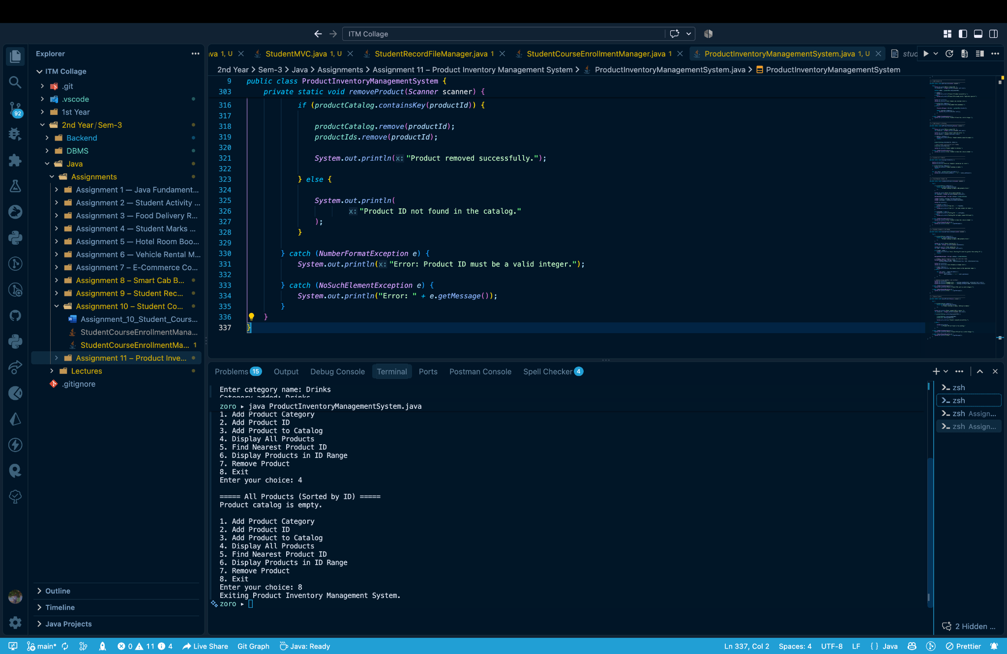
Figure 1: Student Product Inventory Management System execution in VS Code terminal

8. Observed Execution
The submitted execution screenshot shows the Product Inventory Management System running successfully from the terminal. The menu is displayed with all eight required options. A category named "Drinks" is added successfully. The program also demonstrates the display operation when the product catalog is empty and then accepts the Exit option, terminating with the message "Exiting Product Inventory Management System."

9. Requirement Verification
Requirement | Status
HashSet for unique categories | Implemented
TreeSet for sorted, unique product IDs | Implemented
TreeMap for product catalog | Implemented
entrySet() and for-each display | Implemented
floorKey() and ceilingKey() | Implemented
Range query using NavigableMap | Implemented
remove() from TreeMap and TreeSet | Implemented
Scanner + loop + switch menu | Implemented
Exception / invalid-operation handling | Implemented

10. Result
The Product Inventory Management System was implemented as a menu-driven Java console application. The program demonstrates the required Set and Map collections and their operations, including unique storage, automatic sorting, key-value mapping, nearest-key searching, range querying, and product removal. The execution screenshot confirms successful compilation and program execution.

11. Conclusion
This assignment provided practical experience with the Java Collections Framework beyond List-based collections. HashSet, TreeSet, TreeMap and NavigableMap were applied to a realistic inventory scenario. The program also reinforced iteration, user input, menu-driven programming, and exception handling. These concepts are useful for building efficient Java applications that require unique data, sorted data, fast key-based access, and range-based queries.

